**Confidential**





**Software Requirement Specification**

**DWF Portal**

**PMO-533**

**Version 1.4**

**Sep 18, 2018**

COPYRIGHT NOTICE

Copy Right © 2007 MTN Irancell. All rights reserved.

These materials are confidential and proprietary to MTN Irancell. No part of this material may be reproduced, published in any form by any means, electronic or mechanical including photocopy, or any information storage or retrieval system, nor should the materials be disclosed to third parties, without the express written authorisation of MTN Irancell.

**Document Information and Revision History**

**Revision History**

|  |  |  |  |
| --- | --- | --- | --- |
| **Version** | **Changed by** | **When** | **Change** |
| 1.0 | Bahman Heidari Nejad | Aug 12th, 2018 | First Version |
| 1.1 | Saeid Keshmiri | Aug 14th , 2018 | Diagrams updated |
| 1.2 | Reza Asadi | Aug 25th, 2018 | Functionalities updated |
| 1.3 | Bahman Heidari Nejad | Sep 15th, 2018 | Diagram 3.2.1 updated |
| 1.4 | Reza Asadi | Sep 18th, 2018 | Updated (adding reconciliation process and notifications) |

Table of Contents

1 Introduction 3

2 Overview 3

3 Scope 4

3.1 Business functionalities 4

3.1.1 End to End business processes 4

3.1.2 End to End technical processes 5

3.2 Technical functionalities 6

3.2.1 Software architecture and components definition 6

3.2.1.1 Application functionalities 7

3.2.1.2 Roles and ACLs 7

3.2.1.3 DWF Report Rule Management 7

Define Base Rules 7

Update/Edit 8

Export 8

Delete 8

Create exception rule per month 8

3.2.1.4 DWF Report Management 8

Creation 8

Update 9

Export 9

Delete 9

Run 9

Re-run 10

3.2.1.5 Report/Dashboard 10

# Introduction

Irancell vision is “to lead the delivery of a bold, new, digital world to our customer” and based on this vision Irancell wants to provide a service, to be a reference in Interconnect reconciliation with other telecom operators. In this regard, according to a monthly routine, Finance is providing CDR details, separated by provinces, operators, MVNO, etc. as evidence that attached with monthly invoices.

# Overview

Based on Irancell finance team requirement, Parstasmim technical team will develop application to report CDR detail to Irancell finance team systematically and facilitate and accurate this manual job.

This report and relate documents will be generated and delivered by scheduled process to Irancell finance team.

The way of generating report by this tools is based on defined rule by Irancell finance team.

According to importance of information and reports generated by this tools, this tools has facility to manage chain of responsibility.

# Scope

The scope of this SRS can breaks down into following hierarchy:

1. Business functionality
   1. End to end business processes
   2. End to End technical processes
2. Technical functionality
   1. Software architecture and components definition
      1. Application functionalities

## Business functionalities

Following diagram shows end to end processes flow to deliver final service result to MTNIrancell finance team. Gray items show out of project scope and others items are project scope.

### End to End business processes



### End to End technical processes

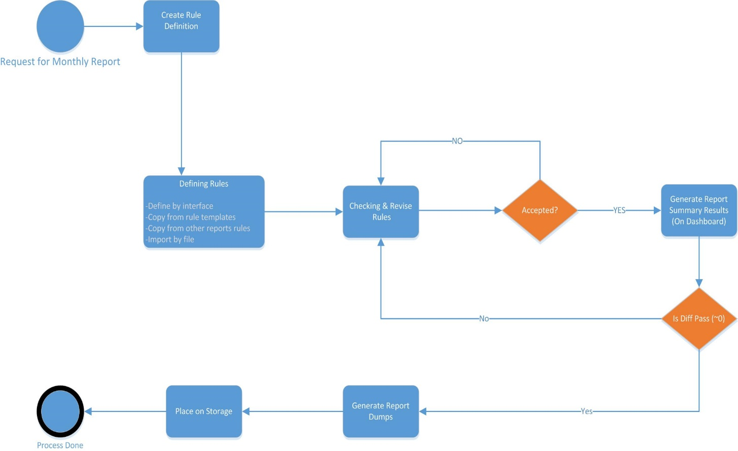

## Technical functionalities

### Software architecture and components definition



#### Application functionalities

DWF analyzer portal function and features are listed as following categories:

* *DWF Report rule management*
* *DWF Report management*
* *Dashboards & Report*

#### Roles and ACLs

The users of DWF analyzer Portal may have one of below roles:

* **Agent:** This role will use to:
  + Define DWF report rule
  + Edit DWF report rule template
  + Clone DWF report rule
  + Create DWF report definition
  + Schedule report
  + View report history result
* **Manager:** This role will use to:
  + Approve request for doing re-run DWF report
  + Viewing reports and dashboard

#### DWF Report Rule Management

In this section application users can Define/Update/Export/Delete DWF report rules.

Each rules contain 3 parts as following:

1. Base rule
2. Base exception rule
3. Exception rule per month

###### Define Base Rules

If there are no any base rules available in system then agent can define Base rules (Base, Base exception) via below interfaces:

1. Create new Base rules definition via Application interface
2. Import from excel file and upload as new Base rules definition

###### Update/Edit

Agent can update/edit Base rules definition via below interfaces and it will be applied for next DWF reports:

1. User can update/edit mentioned rules via defined web forms in portal.
2. User can upload and import new base rules from excel file and replace it on existing rule definition as new version.

###### Export

Agent can get export report rule definition into the excel file.

###### Delete

Agent can delete existing report rule definition which is not linked to any delivered DWF report.

###### Create exception rule per month

Agent can create exception rule for specific month via rule management interface or via DWF report management interface whenever wants to create DWF report for specific month, it will be described in DWF report management section (3.2.1.4).

**Note: All rules definition will be kept in the system for ever. They will store in system monthly basis.**

#### DWF Report Management

In this section application users can Create/Update/Export/Delete DWF report definition and also run/re-run the report at schedule time.

###### Creation

Agent can create report definition for a specific month and set schedule time for running report, system will show the latest rules (base rule, exceptions) which can be applied for mentioned month. User can link the rules or edit if needed then link it to report and save it as exception rule for mentioned month in rule database. Also agent should upload reconciliation file (summary report) with agreed format and set schedule time and save the report. System will send notification to agent and manager to inform them about creation report definition.

If there are no any related exception rules available in system or base rule needs to be updated so agent can create new exception rule or update base rules via below interfaces:

1. Create new exception rule definition via Application interface and save as new version of exception rule for mentioned month.
2. Import from excel file and upload as new version of exception rule for mentioned month.
3. Update the base rules via rule management interface or report management interface.

Also agent can set hierarchical output for each report if needed.

###### Update

Agent can update existing report definition which is not executed via below interfaces:

1. Via application interface
2. Import from excel file and upload it on existing rule definition

###### Export

Agent can get export report definition into the excel file.

###### Delete

Supervisor can delete existing report definition which is not executed.

**Note: All report definition will be kept in the system for ever. They will store in system monthly basis.**

###### Run

The report will be running at defined schedule time and system will generate summary of report. Then system will compare the generated summary with uploaded summary file by user, if there is no diff between them then system will generate related dumps on defined path then system will send completion notification to agent and manager.

If difference has been detected a notification will send to support team to check the issue, support team will check the system exception and fix it execute the report again, if support team has no detected any exception in system then case will be raised to business to investigate an update the exception rules and run it again.

###### Re-run

1. User can re-run report for specific month which already has been executed and generate dumps to defined path.
2. User can edit only exception rule for mentioned month which wants to re-run it and upload new summary file into the system and then execute report again.
   1. System will compare the count of report with the summary file which is uploaded by user if there is no diff then system will generate report dumps to defined path and send notification to agent and manager, if difference has been detected a notification will send to support team to check the issue, support team will check the system exception and fix it execute the report again, if support team has no detected any exception in system then case will be raised to business to investigate an update the exception rules and re-run it.
3. User can re-run report for specific month and specific province or operator also with new rule or linked rule.

**Note: The system will be kept the report result for 6 months so after this period time user cannot re-run the report via this portal.**

#### Report/Dashboard

**Daily Dashboard:**

Below Dashboard will be available in the portal for Manager:

* Date and time of run reports
* Re-run reports
* Reject /Pending reports

**Reports**:

Below Report will be available in the portal for application users:

* Date time run
* User who scheduled the reporting
* Users whose approved reporting steps (Approve rule definitions and approve run)
* Summary of reporting result
* Storage paths where the exported documents to be stored.

**Note: All of report can be exported in excel file.**